Runpod Serverless Deployment Guide

1 Push to GitHub
- Create a new empty repository on GitHub (e.g., yourname/runpod-comfyui-upscale).
- From this project root:
git init
git add .
git commit -m "Initial commit: ComfyUI RunPod Serverless"
git branch -M main
git remote add origin https://github.com/<yourname>/<your-repo>.git
git push -u origin main

2 Build a RunPod Serverless Endpoint (via GitHub)
Open the RunPod console: https://www.runpod.io/console/serverless
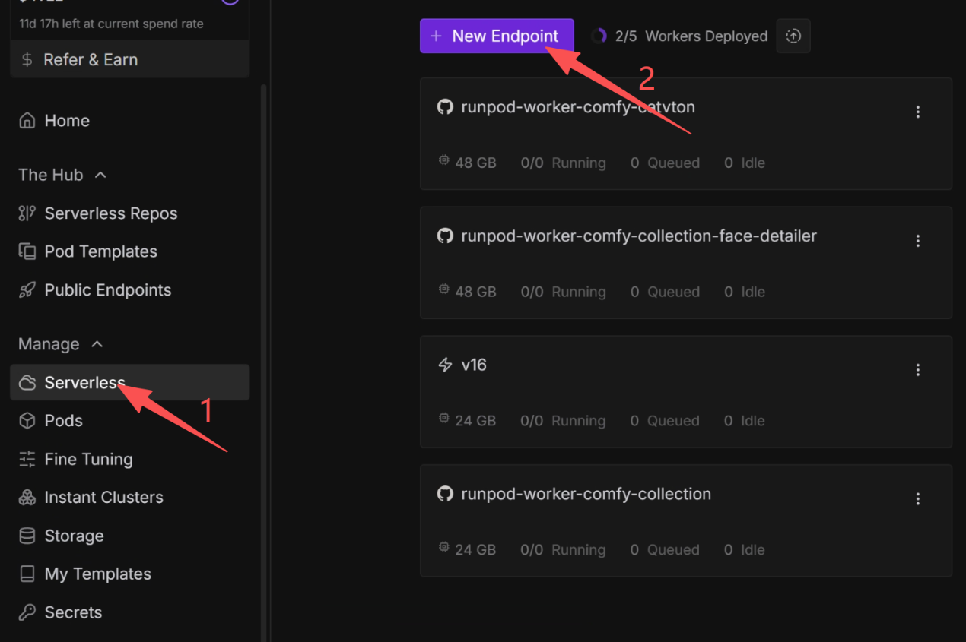
- Click “New Endpoint”.
- Choose Source = GitHub and select your repo/branch (e.g., main).
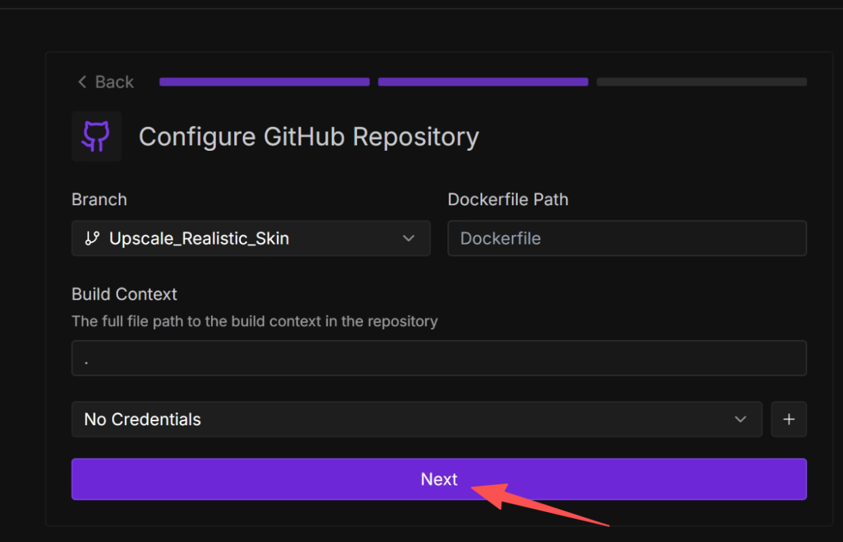
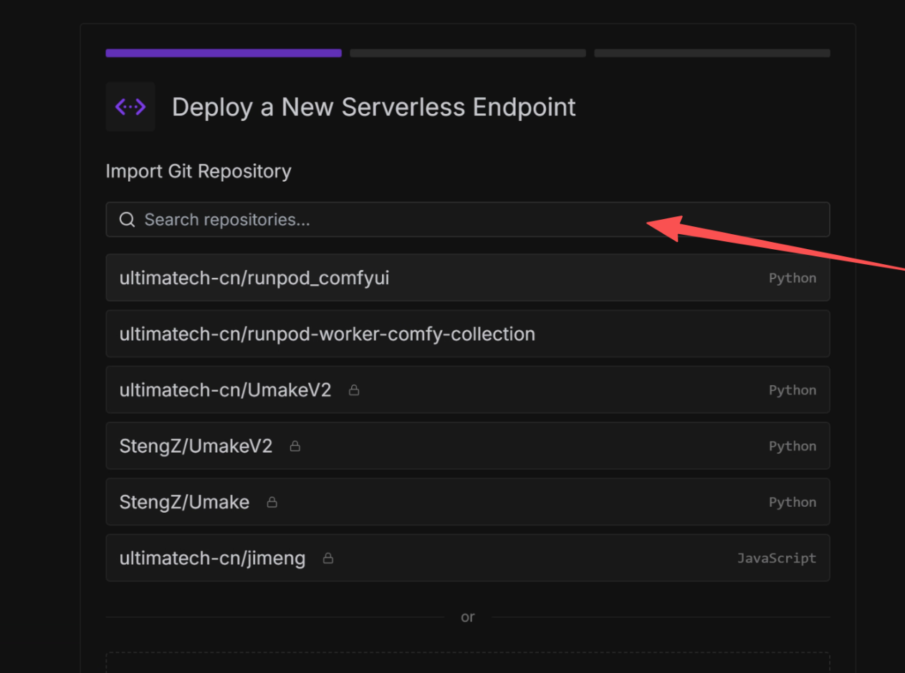
- Suggested settings:

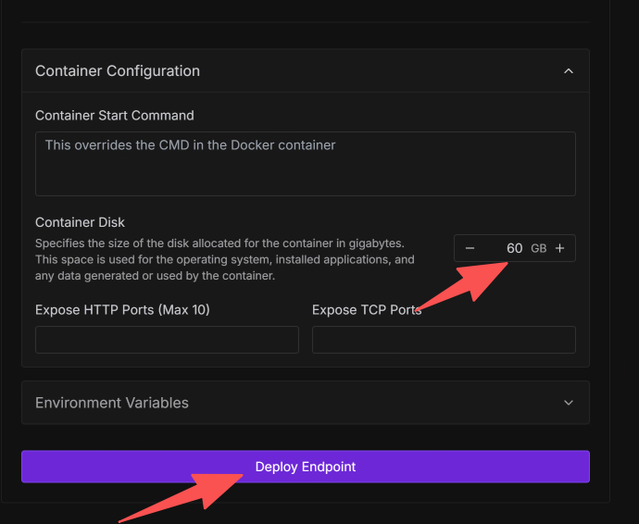
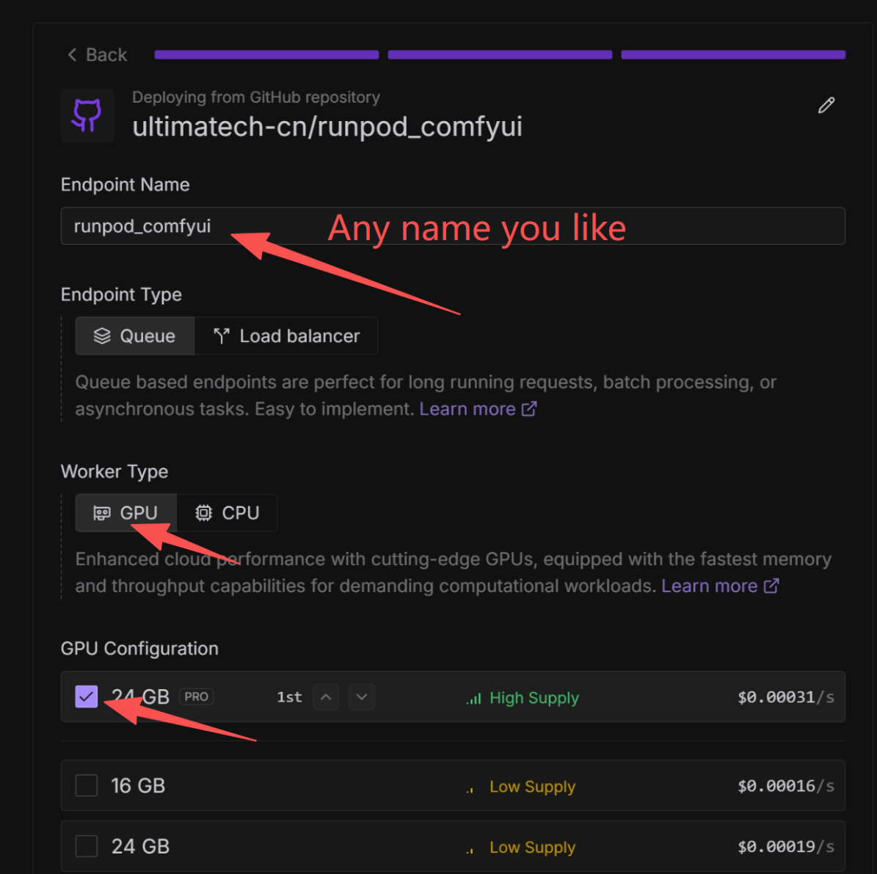
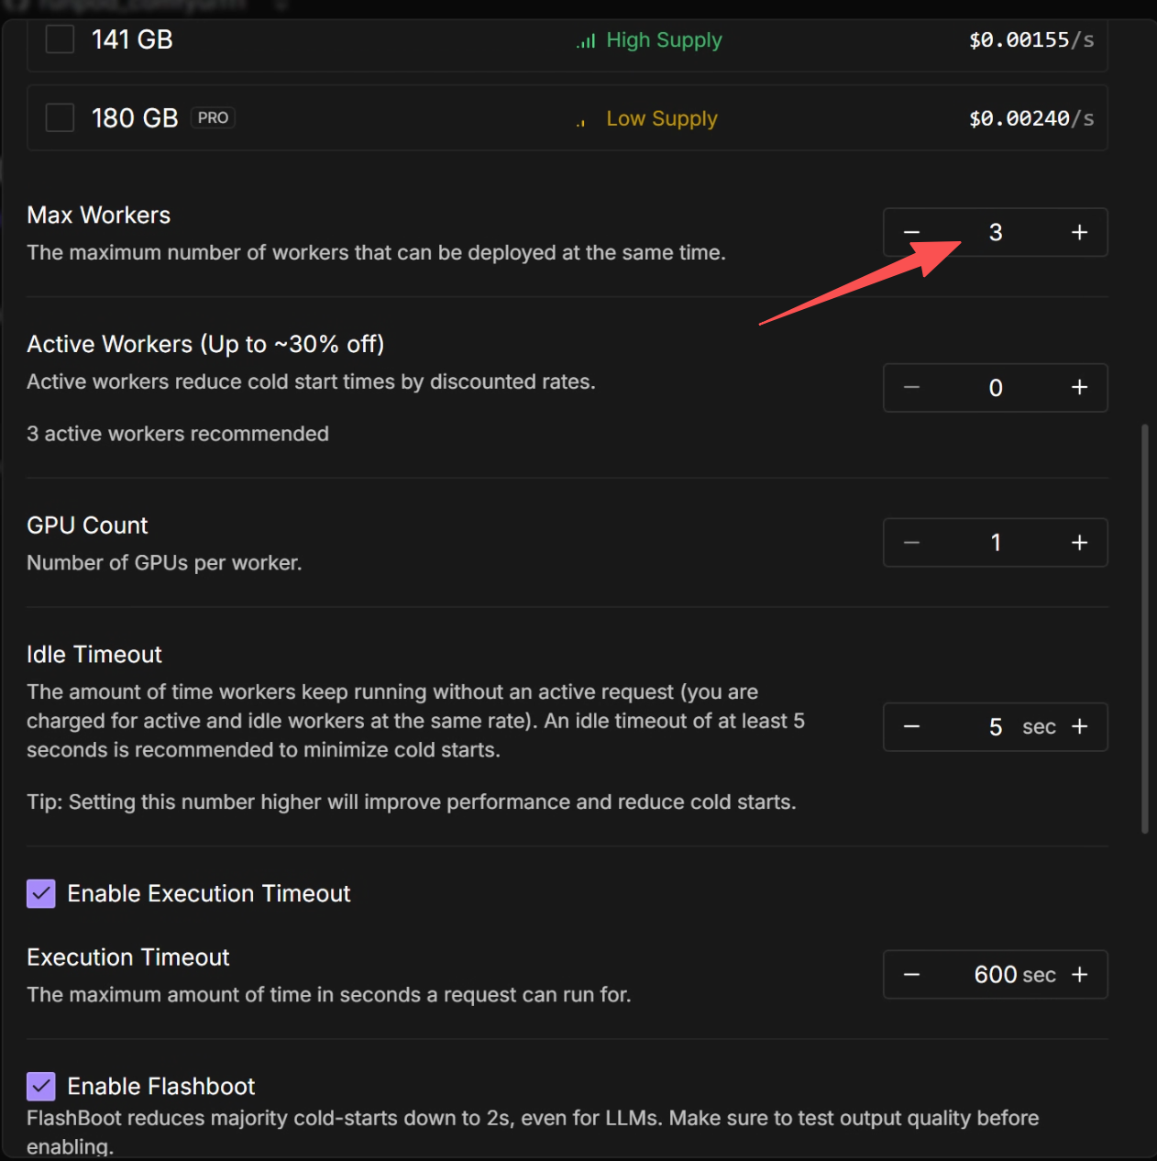
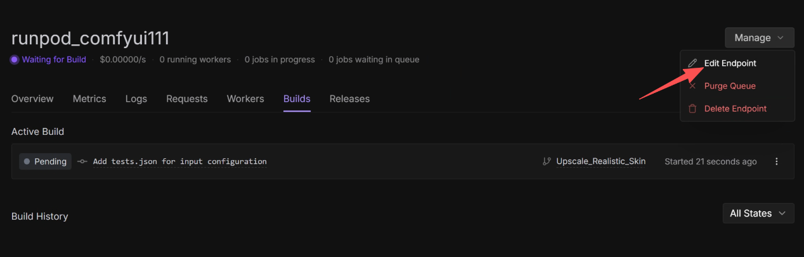
- Modify the number of workers and wait for them to be deployed.

3 Input contract and requirements
- Expected request body:
  - workflow (required): ComfyUI workflow object (JSON).
  - image_url (optional): If provided, the server downloads it to ComfyUI/input and injects it into the LoadImage node.
- The workflow must contain:
  - A LoadImage node (used when image_url is provided).
  - A SaveImage node as the final output.
- Model names in the workflow must exist in the image. By default, the checkpoint is epicrealism_naturalSinRC1VAE.safetensors.
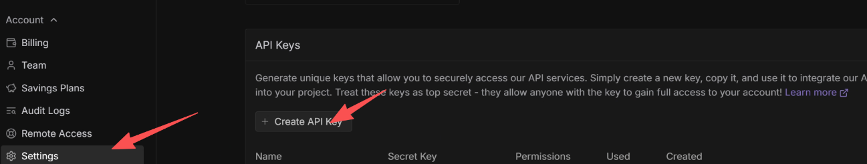
- Remember to get your API key first:

4 Submit job (POST)
Post:
curl -X POST \
https://api.runpod.ai/v2/<endpointId>/run \
-H "Content-Type: application/json" \
-H "Authorization: Bearer YOUR_RUNPOD_API_KEY" \
-d '{
"input": {
"image_url": "https://example.com/your-image.png",
"workflow": { /* Put your ComfyUI workflow object here */ }
}
}'
Response:
{
"id": "<job-id>",
"status": "IN_QUEUE"
}
}

5 Get job result (GET or POST)
Get:
# GET
curl -X GET \
https://api.runpod.ai/v2/<endpointId>/status/<job-id> \
-H "Authorization: Bearer YOUR_RUNPOD_API_KEY"
Post:
# POST
curl -X POST \
https://api.runpod.ai/v2/<endpointId>/status \
-H "Content-Type: application/json" \
-H "Authorization: Bearer YOUR_RUNPOD_API_KEY" \
-d '{ "id": "<job-id>" }'
Response (simplified):
{
"id": "<job-id>",
"status": "IN_QUEUE" | "IN_PROGRESS" | "COMPLETED",
"delayTime": 105,
"executionTime": 134835,
"output": {
"images": ["base64"]
},
"status": "COMPLETED",
"workerId": "<worker-id>"
}
You can use base64_to_file.py to decode images from response.json.

6 Example input JSON and quick verification
Example (same as input.json):
{
"input": {
"image_url": "https://pic.imgdd.cc/item/68ec89ad8dc72b176e8d79b1.jpg",
"workflow": {
"94": { "inputs": { "ckpt_name": "epicrealism_naturalSinRC1VAE.safetensors" }, "class_type": "CheckpointLoaderSimple" },
"97": { "inputs": { "text": "detailed composition, fujifilm, detailed skin, detailed clothing, detailed eyes, masterpiece, best quality, highres", "clip": [ "118", 1 ] }, "class_type": "CLIPTextEncode" },
"98": { "inputs": { "text": "blurry, ugly, deformed, worst quality, low quality", "clip": [ "118", 1 ] }, "class_type": "CLIPTextEncode" },
"99": { "inputs": { "control_net_name": "control_v11f1e_sd15_tile.pth" }, "class_type": "ControlNetLoader" },
"101": { "inputs": { "image": "placeholder_for_upload.png" }, "class_type": "LoadImage" },
"102": { "inputs": { "strength": 1.0, "start_percent": 0, "end_percent": 1, "positive": [ "97", 0 ], "negative": [ "98", 0 ], "control_net": [ "99", 0 ], "image": [ "101", 0 ] }, "class_type": "ControlNetApplyAdvanced" },
"103": { "inputs": { "method": "MultiDiffusion", "tile_width": 1024, "tile_height": 1024, "tile_overlap": 128, "tile_batch_size": 4, "model": [ "150", 0 ] }, "class_type": "TiledDiffusion" },
"104": { "inputs": { "upscale_model": [ "105", 0 ], "image": [ "101", 0 ] }, "class_type": "ImageUpscaleWithModel" },
"105": { "inputs": { "model_name": "4x_NMKD-Siax_200k.pth" }, "class_type": "UpscaleModelLoader" },
"106": { "inputs": { "upscale_method": "lanczos", "scale_by": 1.0, "image": [ "104", 0 ] }, "class_type": "ImageScaleBy" },
"107": { "inputs": { "tile_size": 1024, "overlap": 64, "temporal_size": 64, "temporal_overlap": 8, "pixels": [ "106", 0 ], "vae": [ "94", 2 ] }, "class_type": "VAEEncodeTiled" },
"111": { "inputs": { "tile_size": 1024, "overlap": 64, "temporal_size": 64, "temporal_overlap": 8, "samples": [ "153", 0 ], "vae": [ "94", 2 ] }, "class_type": "VAEDecodeTiled" },
"114": { "inputs": { "b1": 1.05, "b2": 1.08, "s1": 0.95, "s2": 0.8, "model": [ "118", 0 ] }, "class_type": "FreeU_V2" },
"116": { "inputs": { "scale": 1, "adaptive_scale": 0.1, "unet_block": "middle", "unet_block_id": 0, "sigma_start": -1, "sigma_end": -1, "rescale": 0, "rescale_mode": "full", "unet_block_list": "", "model": [ "114", 0 ] }, "class_type": "PerturbedAttention" },
"117": { "inputs": { "lora_name": "more_details.safetensors", "strength_model": 0.25, "strength_clip": 0.25, "model": [ "94", 0 ], "clip": [ "94", 1 ] }, "class_type": "LoraLoader" },
"118": { "inputs": { "lora_name": "SDXLrender_v2.0.safetensors", "strength_model": 1.0, "strength_clip": 1.0, "model": [ "117", 0 ], "clip": [ "117", 1 ] }, "class_type": "LoraLoader" },
"150": { "inputs": { "hard_mode": true, "boost": true, "model": [ "116", 0 ] }, "class_type": "Automatic CFG" },
"153": { "inputs": { "add_noise": true, "noise_seed": 47, "cfg": 10, "model": [ "103", 0 ], "positive": [ "102", 0 ], "negative": [ "102", 1 ], "sampler": [ "155", 0 ], "sigmas": [ "154", 0 ], "latent_image": [ "107", 0 ] }, "class_type": "SamplerCustom" },
"154": { "inputs": { "model_type": "SD1", "steps": 30, "denoise": 0.28 }, "class_type": "AlignYourStepsScheduler" },
"155": { "inputs": { "sampler_name": "dpmpp_3m_sde_gpu" }, "class_type": "KSamplerSelect" },
"161": { "inputs": { "intensity": 0.09, "scale": 100, "temperature": 0, "vignette": 0, "image": [ "111", 0 ] }, "class_type": "FilmGrain" },
"164": { "inputs": { "filename_prefix": "ComfyUI_output", "images": [ "161", 0 ] }, "class_type": "SaveImage" }
}
}
}

